网络工程课程设计
（实验指导书）
题目: 大型传感网络设计--传感网感知数据压缩

Purpose and requirements:
To simulate the compressive sampling, data transmission and data reconstruction process of sensor readings in our campus sensor networks. The detailed requirements are given as follows:
- Encoding of source nodes:
- The node 14 of wireless sensor network observes 512 temperature readings in a certain interval; these original readings can be written as vector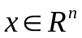.
- We assume that these readings are sparse over certain transform basis（变换基）, which means these temperature data (i.e., vector x) can be transformed into compressible coefficients （系数）by certain transform basis, such as discrete cosine transform (DCT)离散余弦变换
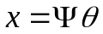
where 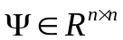denotes表示 DCT basis.
- The node 14 performs compressive sampling on these sensor readings, and which can be shown as:
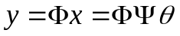
where the measurement matrix 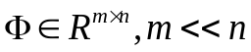; the elements are selected from standard normal distribution.
4) Next, the node 14 transmits the compression data y to the sink node.
- Decoding of sink node:
1) When the sink node received the compression data y, it needs to reconstruct the original data x.
Step 1: the sink node recovers the coefficient vector by CoSaMP algorithm when the matrices 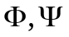and vector y are provided. Meanwhile, we assume that the nonzero number of is s=60.
Step 2: when we obtain the recovered coefficient vector, then we can compute the original data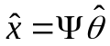.
2) Finally, we need to show the relative recovery error with different number of measurements via simulation figures. The relative recovery error is defined as 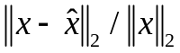, wheredenotes the reconstructed data. The number of measurements selects from set M{2s, 2.5s, 3s, 3.5s, 4s, 4.5s, 5s}.
You need to obtain simulation results, and the template of simulation figure is shown as follows:
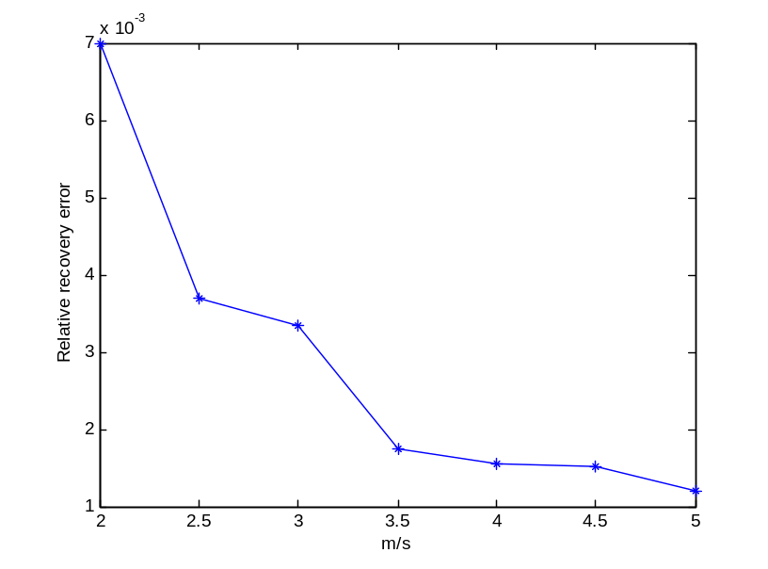
Fig. 1 Relative recovery error with different number of measurements

目的和要求：
模拟校园传感器网络中传感器读数的压缩采样、数据传输和数据重构过程。具体要求如下：
1、源节点的编码：
1)无线传感器网络的节点14在一定的间隔内观察512个温度读数，这些原始读数可以写成矢量。
2)我们假设这些读数在某些变换基上是稀疏的，这意味着这些温度数据(即矢量x)可以通过某些变换基变换为可压缩系数，例如离散余弦变换(DCT)。
这里表示DCT基础。
3）节点14对这些传感器读数进行压缩采样，并且可以显示为：
其中测量矩阵；元素是从标准正态分布中选择的。
4）接着，节点14将压缩数据Y发送到汇聚节点。
2、汇聚节点的解码：
1）当汇聚节点接收到压缩数据Y时，需要重构原始数据X。
步骤1：当矩阵和向量Y被提供时，汇聚节点通过COSAMP算法恢复系数向量。同时，我们假设S的非零数是S＝60。
第2步：当得到恢复系数向量时，我们可以计算原始数据。
2）最后，我们需要通过模拟图来显示不同测量次数的相对恢复误差。相对恢复误差被定义为表示重构数据的地方。测量的数量从集合M {2s，2.5s，3s，3.5s，4s，4.5s，5s}中选择。
需要获得仿真结果，仿真图形的模板如下所示：
图1不同测量次数的相对恢复误差

